Directions to ETSU at Kingsport Downtown
Kingsport Center for Higher Education (KCHE)
Phone: 423-354-5200

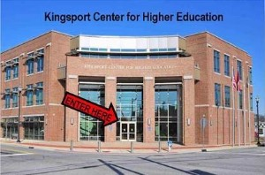

Clay Street parking with handicap spaces

From Hawkins County on 11 W north:
Allandale Mansion to Clinchfield Street is 5 miles
Turn onto Clinchfield Street (HMG Urgent Care)
Follow Clinchfield Street through 3 traffic lights
Turn left onto West Market Street
ETSU is located in the Kingsport Center for Higher Education

From Johnson City:
I-26 West (do not turn left, this will take you to the Allandale location)
Take EXIT 1 and merge right onto 11W north (Stone Drive for 2 miles)
Turn right onto Clinchfield Street (HMG Urgent Care)
Follow Clinchfield Street through 3 traffic lights and turn left onto West Market Street.
ETSU is located in the Kingsport Center for Higher Education.

From Kingsport:
Turn off Stone Drive (11W) onto Clinchfield Street (HMG Urgent Care)
Follow Clinchfield Street through 3 traffic lights and turn left onto West Market Street
ETSU is located in the Kingsport Center for Higher Education.

Meet for Coffee and Muffins on the first day of class, Tuesday, October 9, at 9:30 a.m. in
KCHE room 131!

