Directions to ETSU at Kingsport Downtown Kingsport Center for Higher Education (KCHE) Phone: 423-354-5200

From Hawkins County on 11 W north:
Allandale Mansion to Clinchfield Street is 5 miles. Turn onto Clinchfield Street (HMG Urgent Care).
Follow Clinchfield Street through 3 traffic lights. Turn left onto West Market Street.
ETSU is located in the Kingsport Center for Higher Education.

From Johnson City:
I-26 West (do not turn left, this will take you to the Allandale location). Take EXIT 1 and merge right onto 11W north (Stone Drive for 2 miles). Turn right onto Clinchfield Street (HMG Urgent Care).
Follow Clinchfield Street through 3 traffic lights and turn left onto West Market Street. ETSU is located in the Kingsport Center for Higher Education.

From Kingsport:
Turn off Stone Drive (11W) onto Clinchfield Street (HMG Urgent Care).
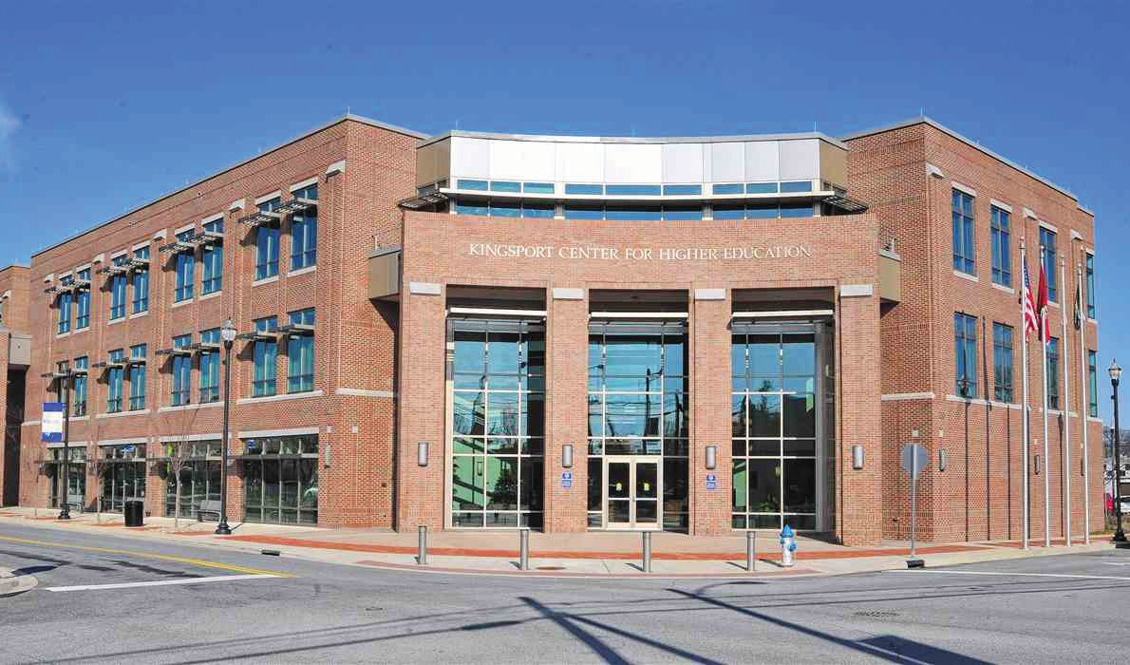
Follow Clinchfield Street through 3 traffic lights and turn left onto West Market Street. ETSU is located in the Kingsport Center for Higher Education.

Clay Street parking with handicap spaces
f
Meet for coffee & muffins on the first day of class, Tuesday, March 12, at 9:30 A.M. in KCHE Room 131!

